SOLAR TRACKER and SUN PATH FINDER

A device that always rotates perpendicular to the rays of the SUN and at the same time records the angles formed by the SUN at the place where the device is set up.

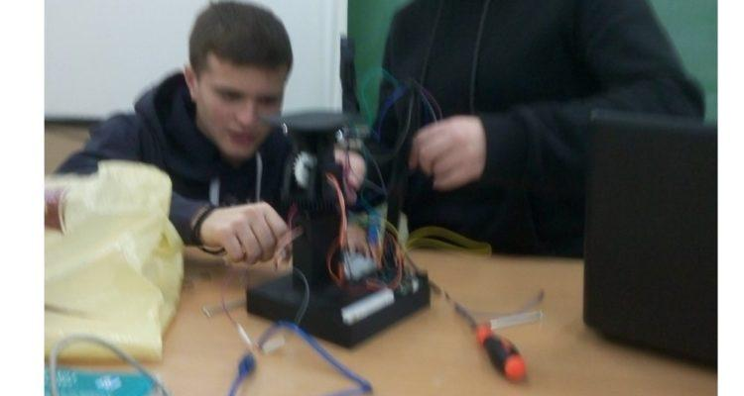

GROUP NAME "HELIATORS": The 1st STEM team that under my guidance after a series of extracurricular laboratory courses built, among other things, the specific [device](https://openedtech.ellak.gr/robotics2020/solar-tracker-epal-kisamou/) following the guide I have in [GITHUB](https://github.com/nektarios25ma/Solar-tracker) and through it any colleague who wishes to build. For this construction, "HELIATORES" received the 3rd [prize](https://openedtech.ellak.gr/2020/11/05/apotelesmata-axiologisis-ergon-tou-2ou-panelliniou-diagonismou-anichton-technologion/) in the competition of [ELLAK](https://ellak.gr/) robotics 2020, which the committee evaluated onlyas a "robotic" device. But I **also developed** it to be an easy-to-use **laboratory** tool for astrophysics (measuring the altitude, azimuth angles of the Sun in real time in the schoolyard).

Detecting the path of the SUN.

In the age of information we find, a researcher finds on the internet either "diamonds" or "garbage" **like nonsense about flat earth**. One of the many ways we show children the scientifically correct truth is with experimental devices like the one I present here.

1. **Study of the current  
   situation in the use of solar energy**

The photovoltaic systems-photovoltaic panels that operate in their majority are static, i.e. they do not turn to the sun and thus according to our sources have a loss of at least 20% of energy.

**b. Clear definition of  
problem - need**

But the sun performs best only when it "falls" perpendicular to the panel, so we look for a way for the panel to follow the sun's rays. One way to monitor it is with photosensitive resistors which are monitored by the arduino microcontroller and with 2 servo the microcontroller adjusts the panel so that the rays fall vertically.

A FEW WORDS ABOUT THE ADVENTURE OF CONSTRUCTION   
The search began with the aim of building a solar tracker such as https://www.instructables.com/id/Building-an-Automatic-Solar-Tracker-With-Arduino-N/.  
BUT all these constructions are for indoor space and for demonstration purposes (it is a light tracker) and not for a real solar tracker.

1. **Definition of a proposed solution-originality of differentiation**

**And here I entered the great adventure of building a real solar tracker and as a natural consequence (application of astrophysics) and solar pathfinder- scientific tool for finding the angles that the SUN erases in our area.**  
And I redesigned our project to cover the angles that the sun erases in our area - a complete study of' *motion can be* the *SUN* found on github as *sun path* [*https://drive.google.com/file/d/1GLD8PmXYanXQI7J_CQ0ZFBPLYN2PAc? usp = sharing*](https://drive.google.com/file/d/1GLD8PmXYanXQI7J_CQ0ZFBPLYN2PAcjO/view?usp=sharing)(power point) which is suggested together with analogous videos to explain the operation of the device. Video: <https://www.youtube.com/watch?v=OR8EQ0DWpPw&t=49s>

EXPLANATION OF THE GROUP constructed under the guidance MY PROJECT, VIDEO

LINK: https://www.youtube.com/watch?v=emRvdH7JC2I&t=79s SOLAR PATH FINDER AND SOLAR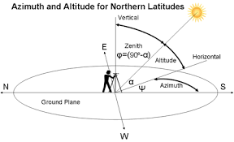

There are two ways of determining the azimuth.

LABORATORY PROCEDURE

1. EXPLANATION-LESSON IN THE CLASSROOM WITH : [Power point presentation](https://drive.google.com/file/d/1GLD8PmXYanXQI7J_CQ0ZFBPLYN2PAcjO/view?usp=sharing) , discussion and [video](https://www.youtube.com/watch?v=OR8EQ0DWpPw&t=49s)

2. Using a device in the courtyard and exporting a graph * such as:

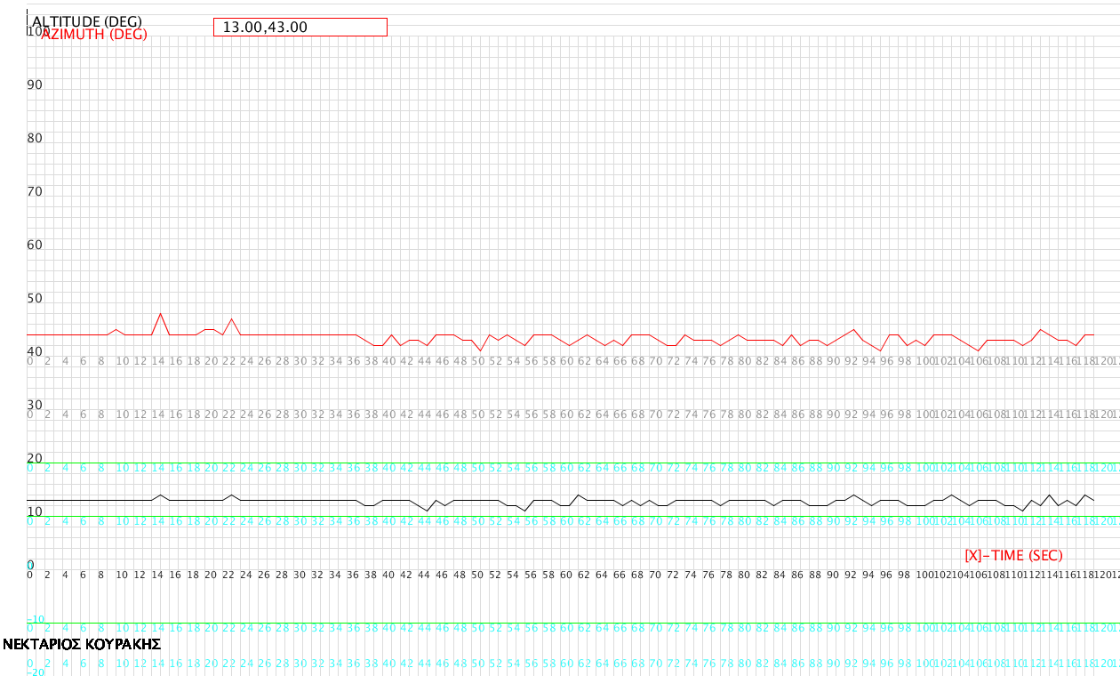

22-12-2020 09:00 UTC + 2

* I have created a graphical environment through processing ide on pc or laptop for ***live*** display of the corners of the Sun - which it receives via Bluetooth from the device - and saves the results. We measure the azimuth here in the 2nd way so in order to control the result we do the operation e.g. here 1800 -430 = 1370 .

[Web page](https://www.suncalc.org/#/35.5322,24.082,3/2020.12.22/10:00/1/3) astrophysics given by the angles of the sun depending on the area to compare results and find the percentage deviation from the graph we find.

**We repeat the experiment 1 month later at the same hour, find different results and talk about this fact in class**.

Detailed instructions for using the device on [GITHUB](https://github.com/nektarios25ma/Solar-tracker/blob/master/%CE%9F%CE%94%CE%97%CE%93%CE%99%CE%95%CE%A3%20%CE%A7%CE%A1%CE%97%CE%A3%CE%97%CE%A3%20%CE%A4%CE%97%CE%A3%20%CE%A3%CE%A5%CE%A3%CE%9A%CE%95%CE%A5%CE%97%CE%A3%20%CE%9C%CE%91%CE%A3.docx).

CONSTRUCTION: (from here to the penultimate page is the construction method, so in a first reading it can be omitted)

Materials (final report):

1. arduino uno (https://grobotronics.com/funduino-uno-rev3-arduino- uno-compatible.html) = € 11.90  
2. 4 ldr (https://grobotronics.com/photo-resistor-ldr-5mm.html)=4*0,20=$ 0,80  
3. * 2 servo (link : https://grobotronics.com/servo-small-5kg.cm-metal-gears-with-analog-feedback-feetech-fs9225m.html  
https://grobotronics.com/analog-feedback-micro-servo-plastic- gear.html  
) = € 9.90 + € 12.20 = € 21.10  
4.wires (https://grobotronics.com/jumper-wires-15cm-female-to-male-pack-of-10.html AND https: / /grobotronics.com/jumper-wires-15cm-male-to-male-pack-of-10.html)=2*$1.80=$ 3,30  
5..breadboard (link: https://grobotronics.com/ breadboard-400-tie-point-white-half-size.html) = € 3.20  
6.Bluetooth Module for Arduino - HC05 (https://grobotronics.com/bluetooth-module-for-arduino-hc05.html) = € 6.80

7. 4 resistors 1kohm (https://grobotronics.com/carbon-1-4w-5-1kohm. html) = € 0,04

8.servo arm (https://grobotronics.com/servo-arm-double-5cm-horn-spline-25t.html) = € 1.90

9. 4mm screw with length 9cm = € 0.10  
10 .Plastic gears from 3D printer of the exhibitions (STL ARCHIVES INCLUDED AS ST1, ST2, ..)  
INDICATIVE TOTAL = € 49,00

We tested the solar panel outdoors-https: //grobotronics.com-3solar-pan w-165x135mm.html-on our solar tracker, which easily charged a smart phone.

*SOFTWARE*

*1) ARDUINO IDE*

*2) TINKERCAD-ONLINE 3D DESIGNER* [*https://www.tinkercad.com/*](https://www.tinkercad.com/)

3) PROCESSING IDE

TOOLS

1) Screwdriver-screwdriver

2) Paper cutter for removing imperfections from 3D components.

FINAL PROBLEM DESCRIPTION Our age requires large energy reserves, so an efficient photovoltaic panel that follows our sun shows the way to the manufacturers of photovoltaic systems. ***Especially when our project records the angles created by the sun on the mainland in Chania and thus shows per day and time the appropriate angle that the f-panel must have for maximum efficiency. A scientific work of this kind trains future scientists in the STEM-Positive Science-Robotics interdisciplinary framework. Following the path of the*** *sun .*Following the previous answer, our idea is to build a solar tracker that will adjust our photovoltaic panel perpendicular to the sun's rays to have maximum efficiency and at the same time will record these angles. We will use 4 ldr photo resistors the light sensors that depending on the light they receive will command our panel to rotate to the correct position - 2 servos to execute the above commands and will also be **tilt sensors \***to record these angles. Of course arduino which is the brain of our construction. 3D printed parts will give stability and efficiency to our construction.

* (With 3D components we made two identical constructions. The first-link https://github.com/nektarios25ma/Solar-tracker/tree/master3- uses an independent 9-axis MEMS sensor with extra MCU to give the gradients and the second **most frugal** with sensors slopes themselves servo * additionally has the advantage that it can track-record **all** angles deletes the sun during the time for it has**re-designed** all 3D components from our group. (For this reason **we chose to present it as the main construction)**

***CONSTRUCTION-Here as in github -in more detail- I describe the way it is constructed.***

You will find the designed 3d components from our team as stl files on github. The servo that is in our list "clicks" exactly on the above components.

The servo: https://grobotronics.com/servo-small-5kg.cm-metal-gears-with-analog-feedback-feetech-fs9225m.html

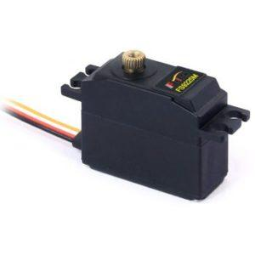

"clicks" on the 3d component**base.stl (or stl 1) -in slot you see,**

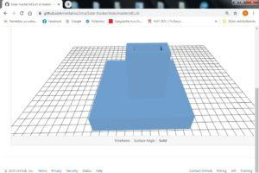

Put the servo arm on the servo (https://grobotronics.com/servo-arm-double-5cm-horn-spline-25t.html).

AS IN FIGURE 1

FIGURE 1:

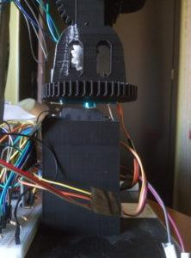

On the servo arm screw the 3d component**panel-mount.stl (or stl2)**

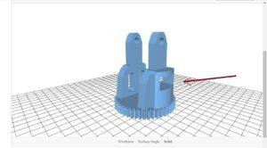

**and place the 2nd servo (where the arrow shows)**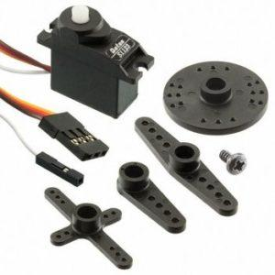

in the appropriate opening of **panel-mount.stl,**as in picture 2 :

Figure 2

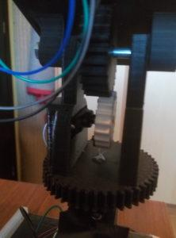

In the 2nd servo we screw the**Vertical_Servo_Gear.stl (or stl5, the white in the picture2)**

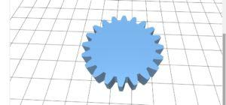

As in the picture 2.

In the **Panel Bracket.stl (or stl4) we**

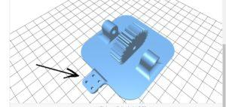

Place the **LDR DIVIDER HIGH.stl (or stl3) where the arrow shows (has a slot to accept it and let it not appear in the picture above).**

**LDR DIVIDER HIGH.stl:**

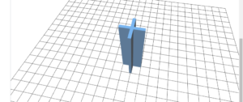

Finally with the appropriate screw 4mm with a length of 9cm and the corresponding nuts we place the **Panel Bracket.stl as in picture 2.**

The connection must be done as *(circuit)*

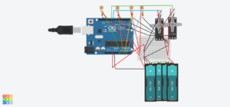

And the bluetooth hc-05-connection we quote it in another image because the tinkercad-circuit from which we made the above image does not have a bluetooth element

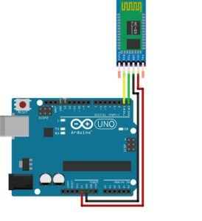

**ALL THE FILES ARE LOCATED ON GITHUB WITH GREATER RESOLUTION.**

Then we had to calibrate the servo to measure the right angle and in this laborious process the 2nd link helped (see the file on github -*calibration process* that explains in detail).

The voltage divider shown on the circuit located on github (and above) finally worked well outdoors with 500 ohm resistors (4 resistors). Depending on the behavior of the ldr we choose (experimentally) corresponding resistors so that outdoors they work satisfactorily.

BIBLIOGRAPHY REFERENCES

1. <https://en.wikipedia.org/wiki/Sun_path>2)<https://en.wikipedia.org/wiki/Position_of_the_Sun>3)<https://www.youtube.com/watch?v=lJVEubm9Ja8>4)[https : //www.instructables.com/id/Arduino-Solar-Tracker/](https://www.instructables.com/id/Arduino-Solar-Tracker/)
2. LINK THAT HELPED IN THE CALIBRATION SERVO *: https://dronebotworkshop.com/analog-feedback-servo-motor/

Ο ΒΑΣΙΚΟΣ ΑΛΓΩΣΜ HIS OPERATING LOGIC IS DESCRIBED BELOW

[ALGORITHM-FLOWCHART](https://openedtech.ellak.gr/wp-content/uploads/sites/31/2019/11/%CE%91%CE%9B%CE%93%CE%9F%CE%A1%CE%99%CE%98%CE%9C%CE%9F%CE%A3-FLOWCHART.pdf)

(click-click on) https://openedtech.ellak.gr/wp-content/uploads/sites/31/2019/11/%CE%91%CE%9B%CE%93%CE%9F%CE%A1%CE%99%CE % 98% CE% 9C% CE% 9F% CE% A3-FLOWCHART.pdf Utilities were

also used to calibrate servo *.

**AT THE LINK * FOLLOWING**  **IS MOUNTED*ALL FILES THAT ARE NECESSARY*FOR THE UNDERSTANDING AND CONSTRUCTION similar EGCHEIRIMATOS**LINK: https://github.com/nektarios25ma/Solar-tracker

(branchmaster)

